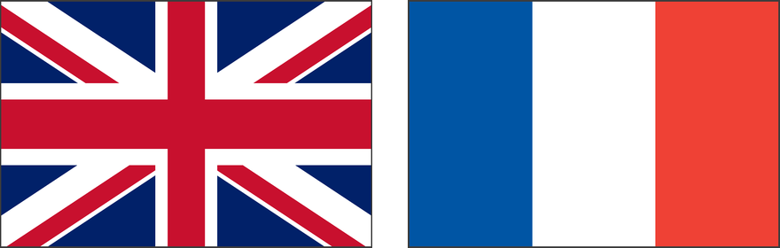
Weymouth-Louviers Twinning Society
Membership Application Form

Membership fee for 2026: £20 per person
Full Name:

Address:

Postcode:

Contact Email:

Telephone Number:

Do you speak French? | ☐ Yes | ☐ No

Payment Details
By cheque: please make cheques payable to “Weymouth Louviers” and send with your completed form to the address below.
By BACS transfer:
Account number: 24899068
Sort code: 30-99-56

Please return this completed form, together with your membership fee, to:
The Chairman
C/O 5 Sussex Road
Weymouth, Dorset
DT4 0PL

